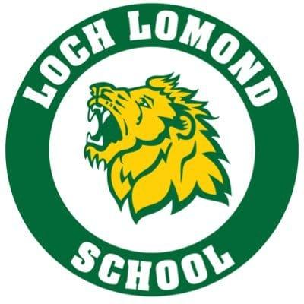

Loch Lomond Home and School Association

Loch Lomond Home and School is excited to once again partner with Java Moose!

All coffee choices can be purchased for $11: ½ lb Whole beans
½ lb Grinds
12 K-cups

AVAILABLE ROASTS: Foghorn (dark roast)
SWP Colombian Decaf (Swiss Water Process - not chemically decaffeinated)
Bay of Fundy (medium roast)
Cookies & Cream
Cocoa Mocha Nut
Vanilla Buttercream
Butter rum Fudge Hotlunches.net
Canadian Maple

- Orders will be received through HotLunches.net
- Orders are due no later than Feb 29th @11:59pm
- Order pick-up will be week of March 21st
- Prizes for Top Sellers

- We hope to make this fundraiser a huge success and thank each of you for your participation.
- All funds raised by the Home and School Association goes directly to support our school.

Follow us on Facebook
for information on upcoming events Loch Lomond Home and School Facebook Group
If you have any questions,
would like to join your Home and School Association
or become an in-person volunteer,
please email us at
LLHOMEANDSCHOOL@GMAIL.COM

